**The Ark Documentation.**

**Admin Guide (includes all admin functionality)**

This particular guide steps away from our pervious “self-contained single functionality” guides because the Admin module is extremely critical to the functioning of The Ark. Everything you do in this module could have a critical affect on other components. Each functionality roles on from the next and the overall theme that you shouldn’t need to, or often want to change this functionality needs to be clear any time you think of touching this section. This is why the functionality is not even visible to anybody but the ark super user account.

Log in with your **ark super user account**. You do not need to select a study. Select the Admin Tab

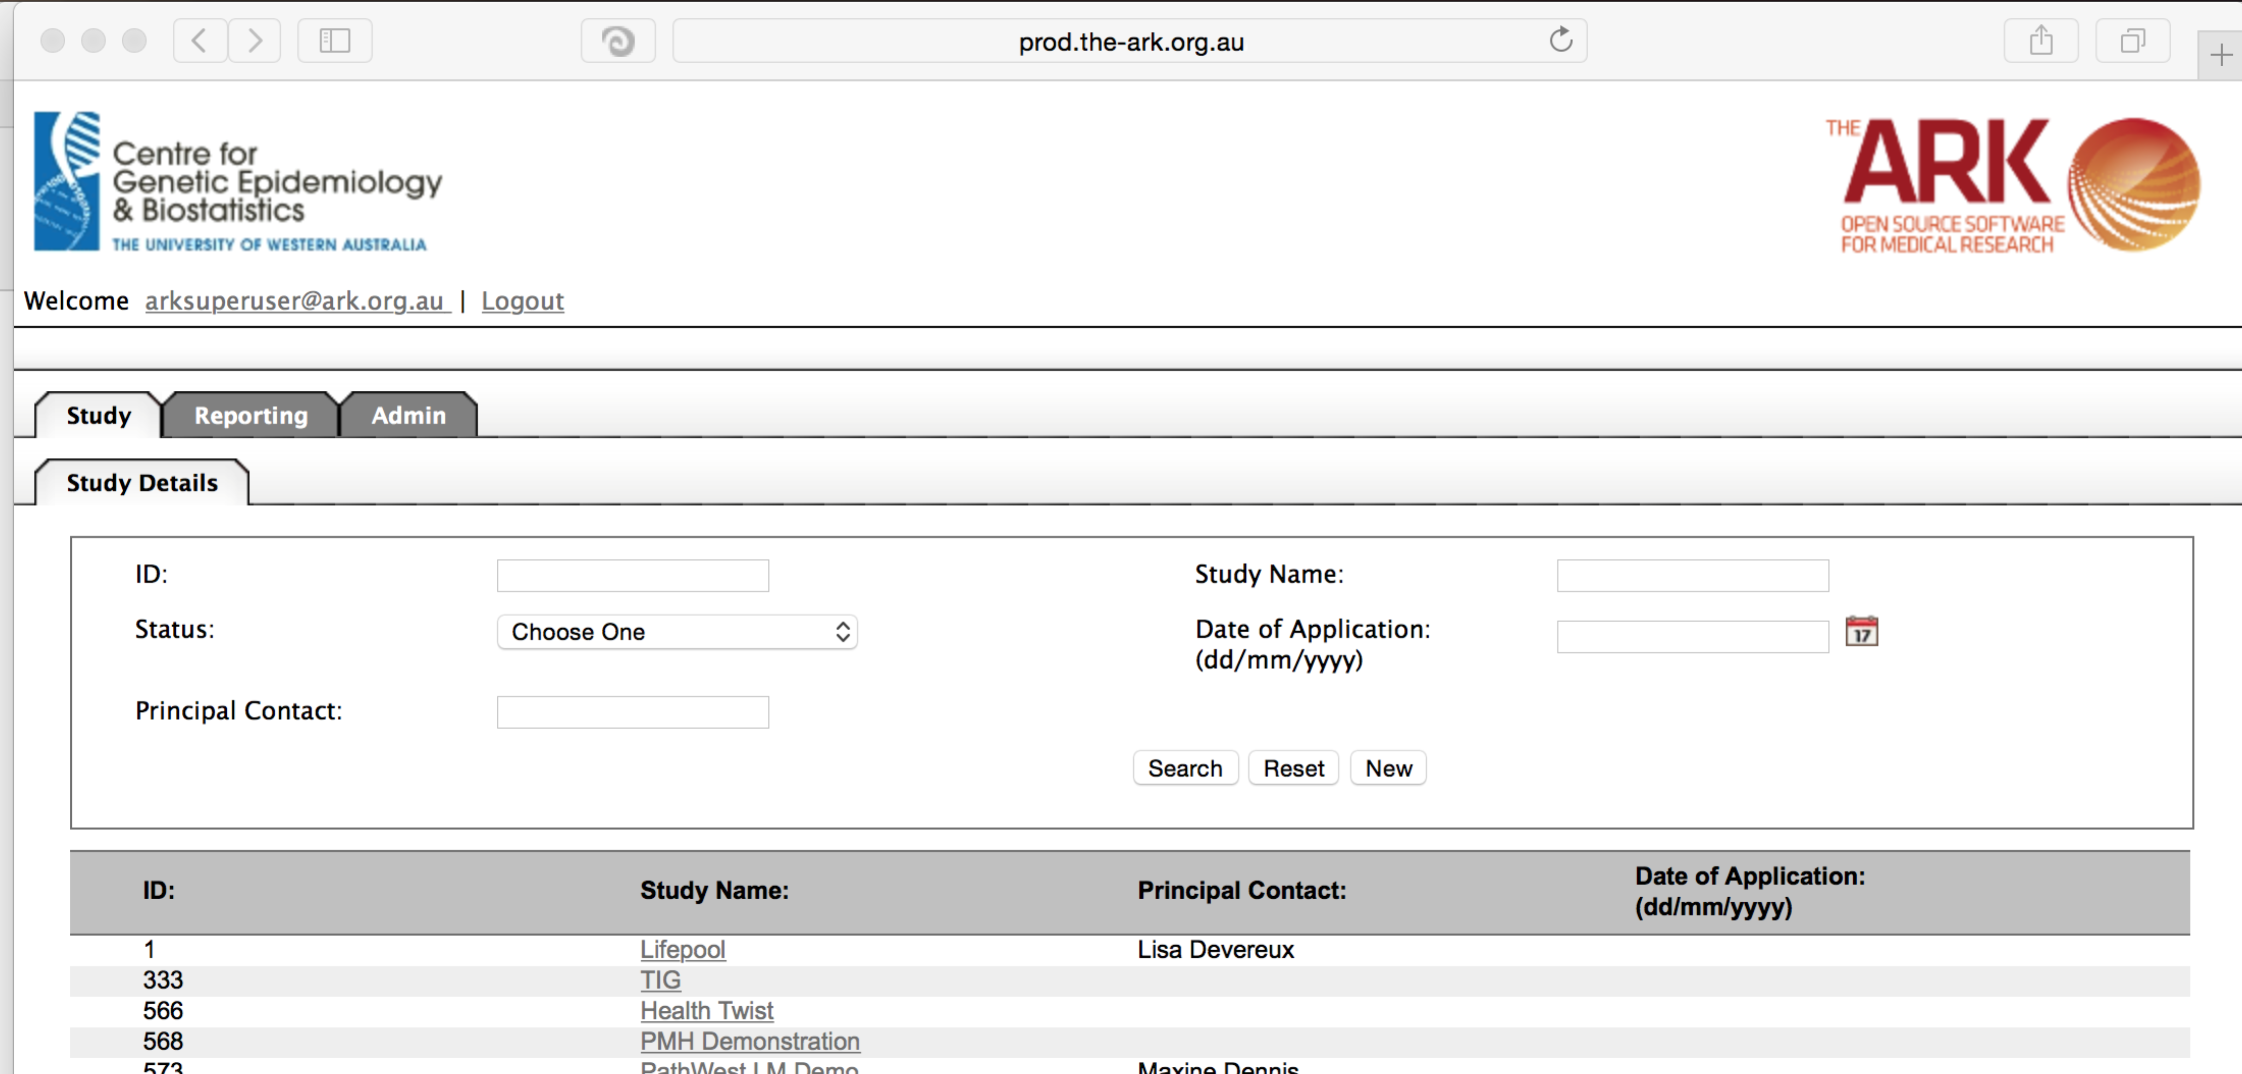

NOTE: Most admin functions, while available, will never be altered. The setup scripts when you create an instance of The Ark set this all up for you, and changes to this area may ultimately require further java coding changes and database changes in order to allow that functional change to occur. These facilities are mostly here so that you can see if a new instance has all that it needs in the database in order for The Ark to function.

However as a convenience we can remove certain roles, modules, etc, here. We just need to be aware that there could be downstream affects.

The most useful functions are session/activity monitoring and are useful in the realm of security and forensics.

The first function highlighted is “Module”. This is a list of all available modules. We see two inactivated modules are listed here (they are in the database yet the java application logic is not active), yet they are not available now (Genotypic and Disease modules).

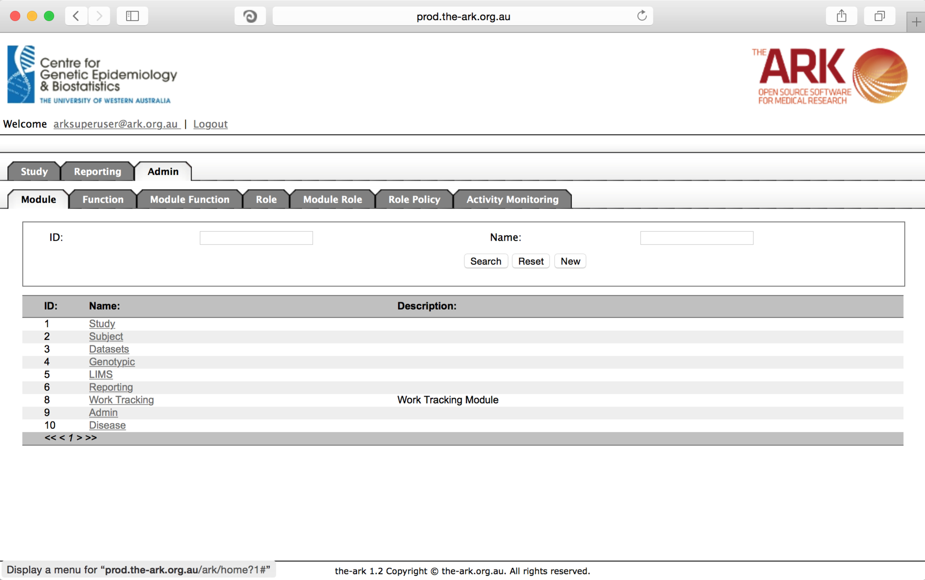

The next function we look at is the “Function” tab. This lists all available functions (pages). Again, we would not want to alter these without first creating the java/database code in order to enable it.

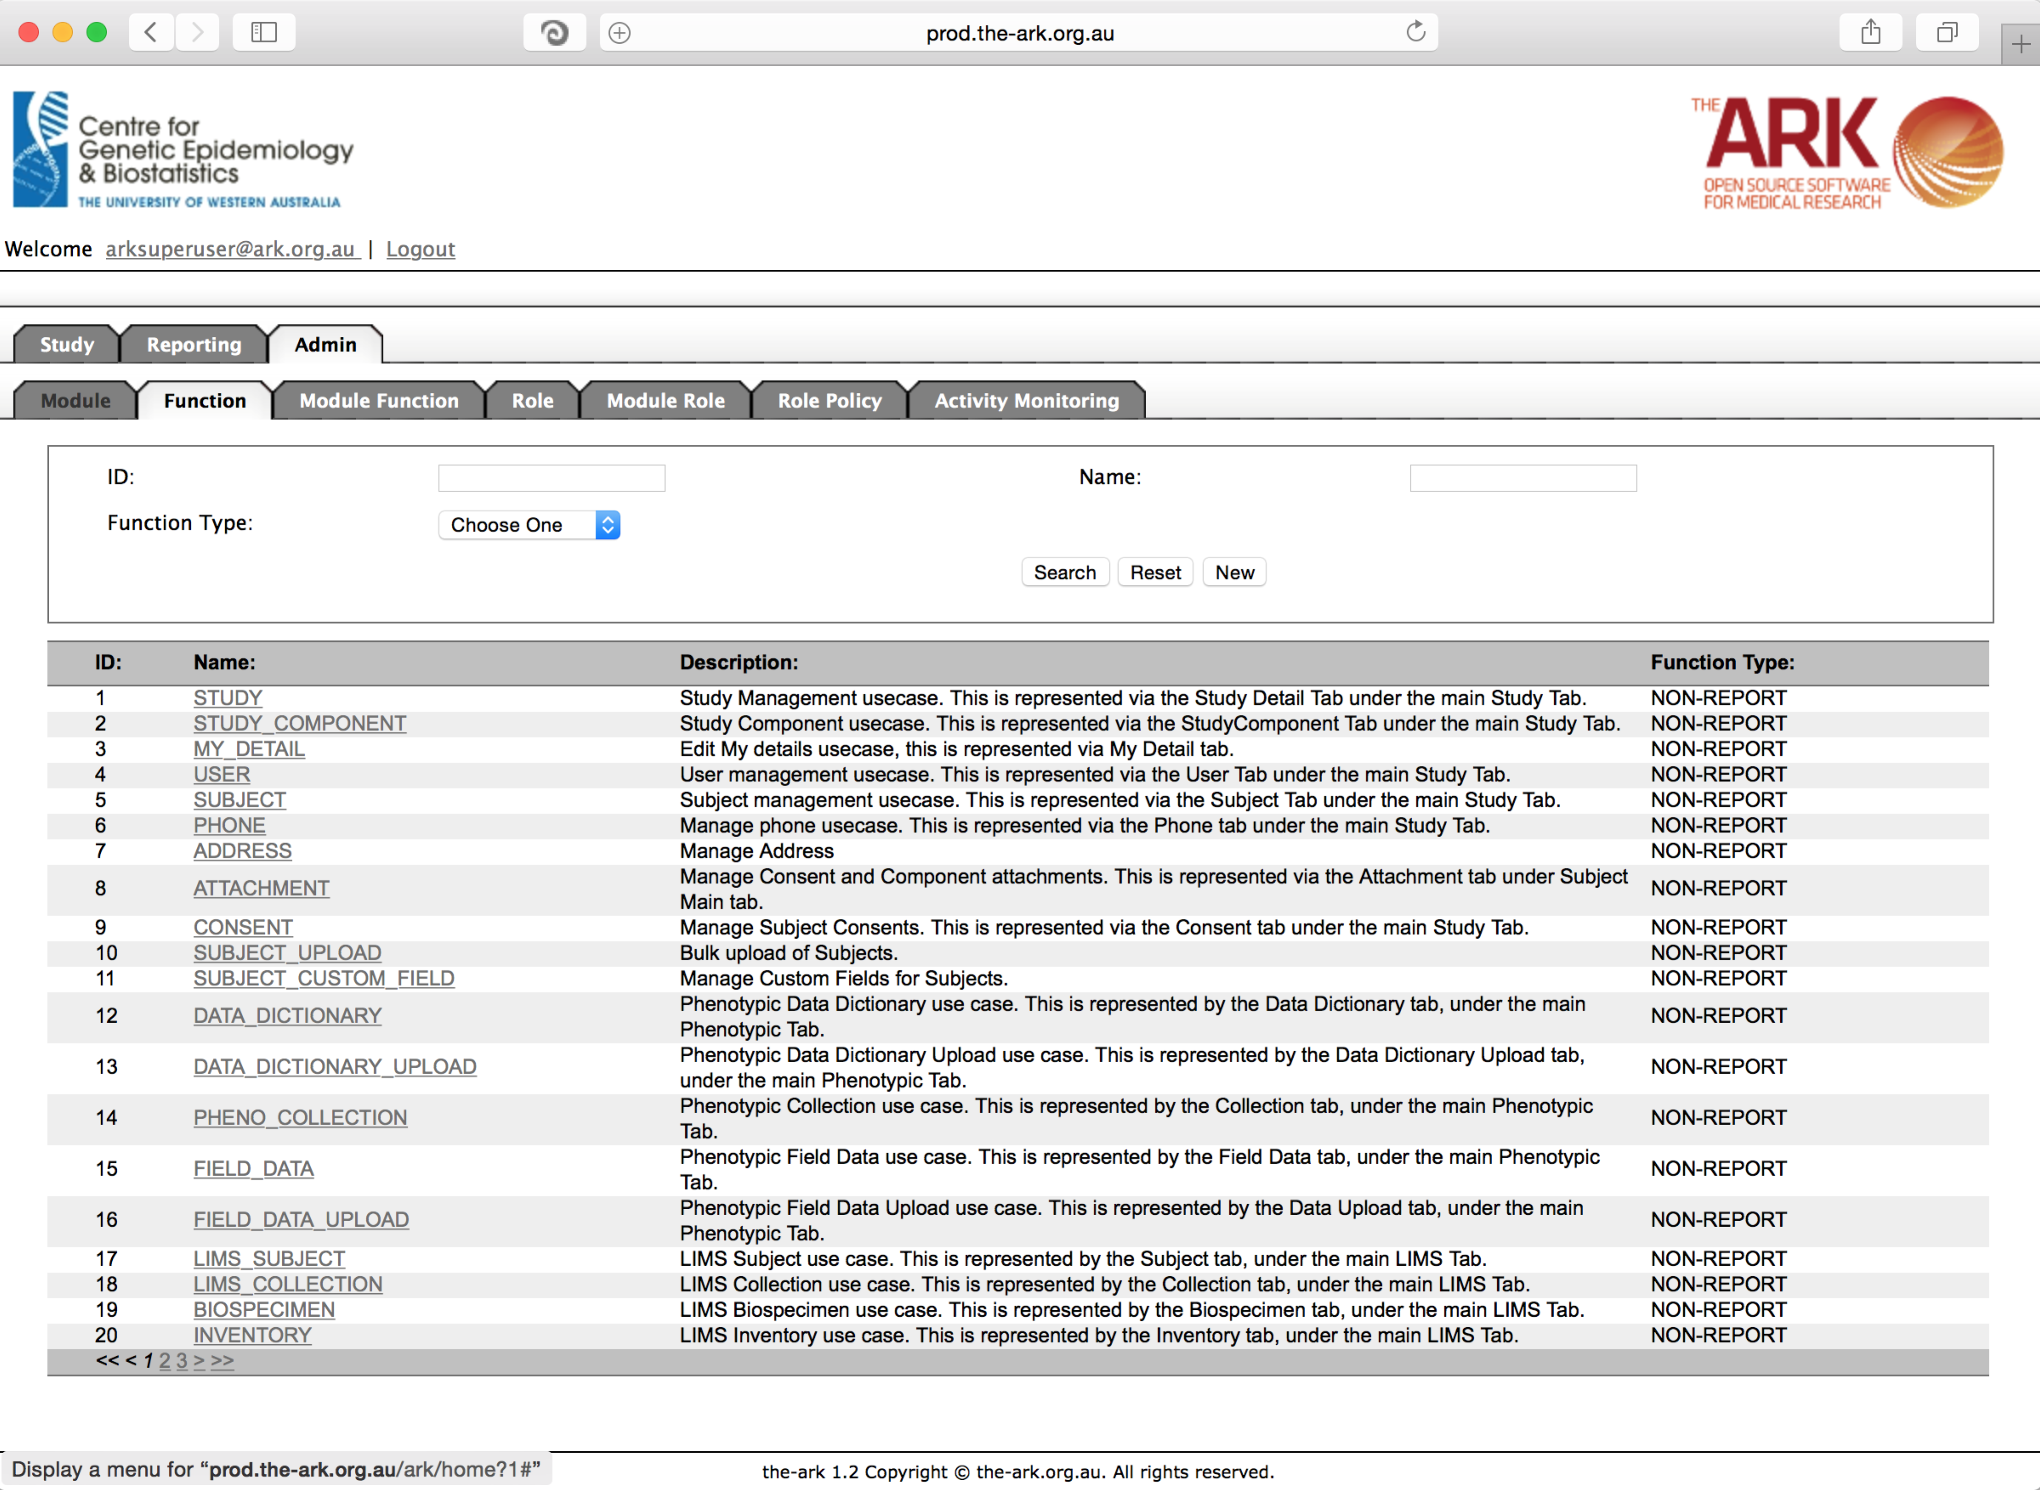

Assuming we did all of the necessary java and database changes to facilitate the need for a new function, we can list its availability here and make sure that it’s reference were clear here.

As with all our modules/functions we have the exact same search/create/update look as always. Click new to create your new module, and then fill out the details similar to below. Please follow standard protocols and capitalisation in the same way you see in this example. That way fellow developers know what to expect when referencing this function (e.g.; in wicket applications). Click save.

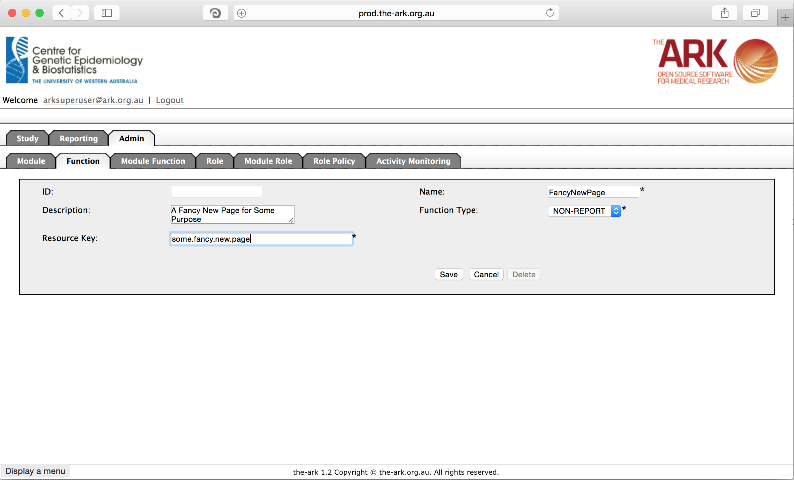

Assuming you now have your modules and functions as expected, you can arrange where they are displayed (again, this is likely to have some interaction with java code, so please do not administer this unless you are capable of dealing with any java code which may need altering). This was originally designed to be completely independent, however some more recent development may have involved dependencies between modules/functions. So please step carefully.

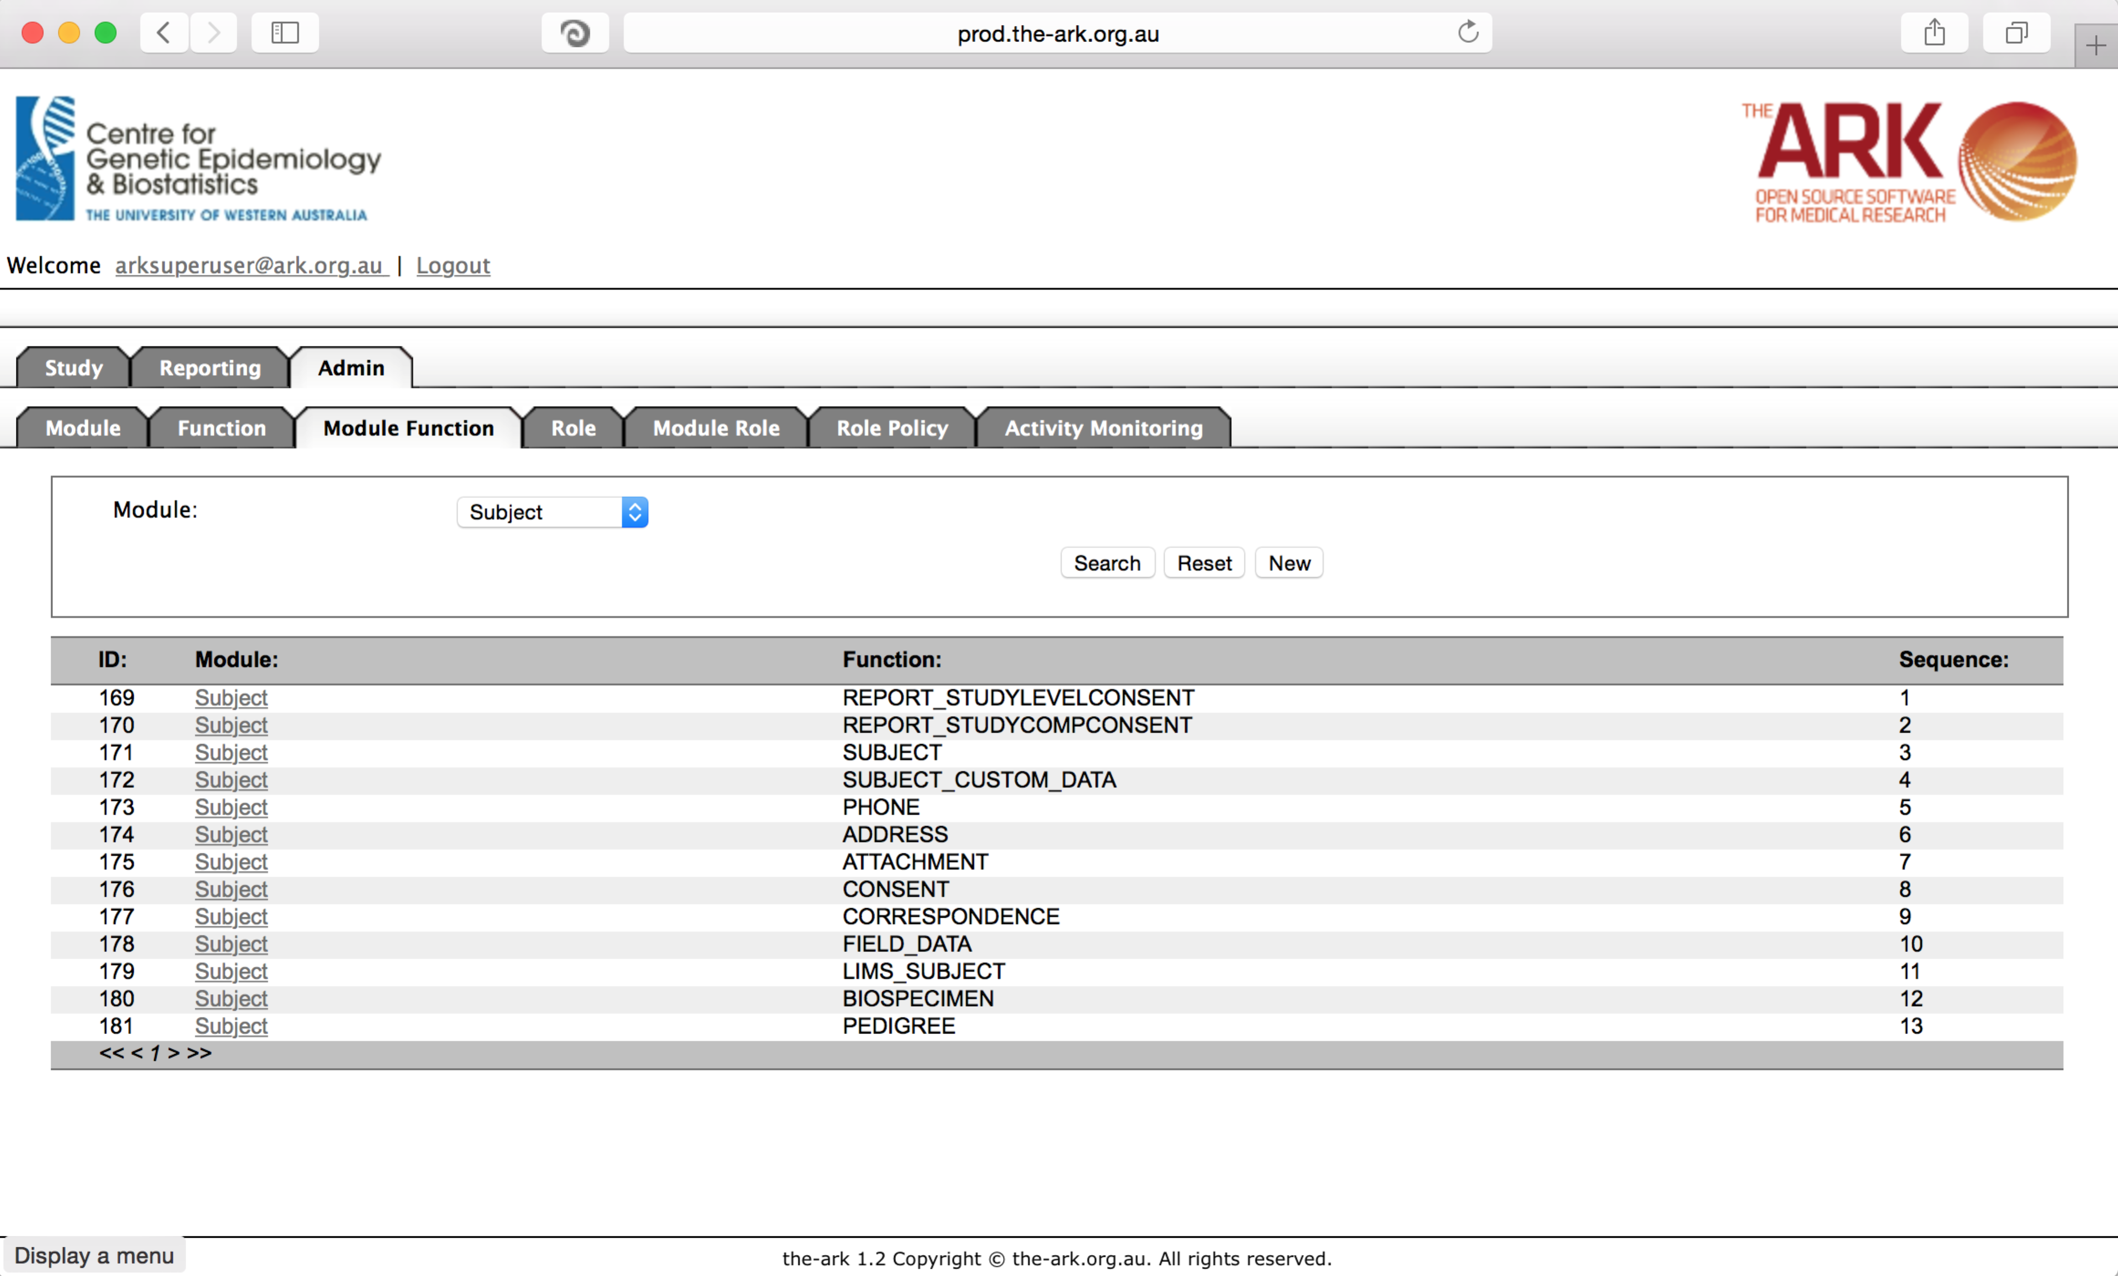

As you can see, you can filter by module to have a look at what functions are there and their order. If you simply wish to change priorities this should theoretically have no effect. To make changes, simply click on the module wish to alter available functions for. This page will appear;

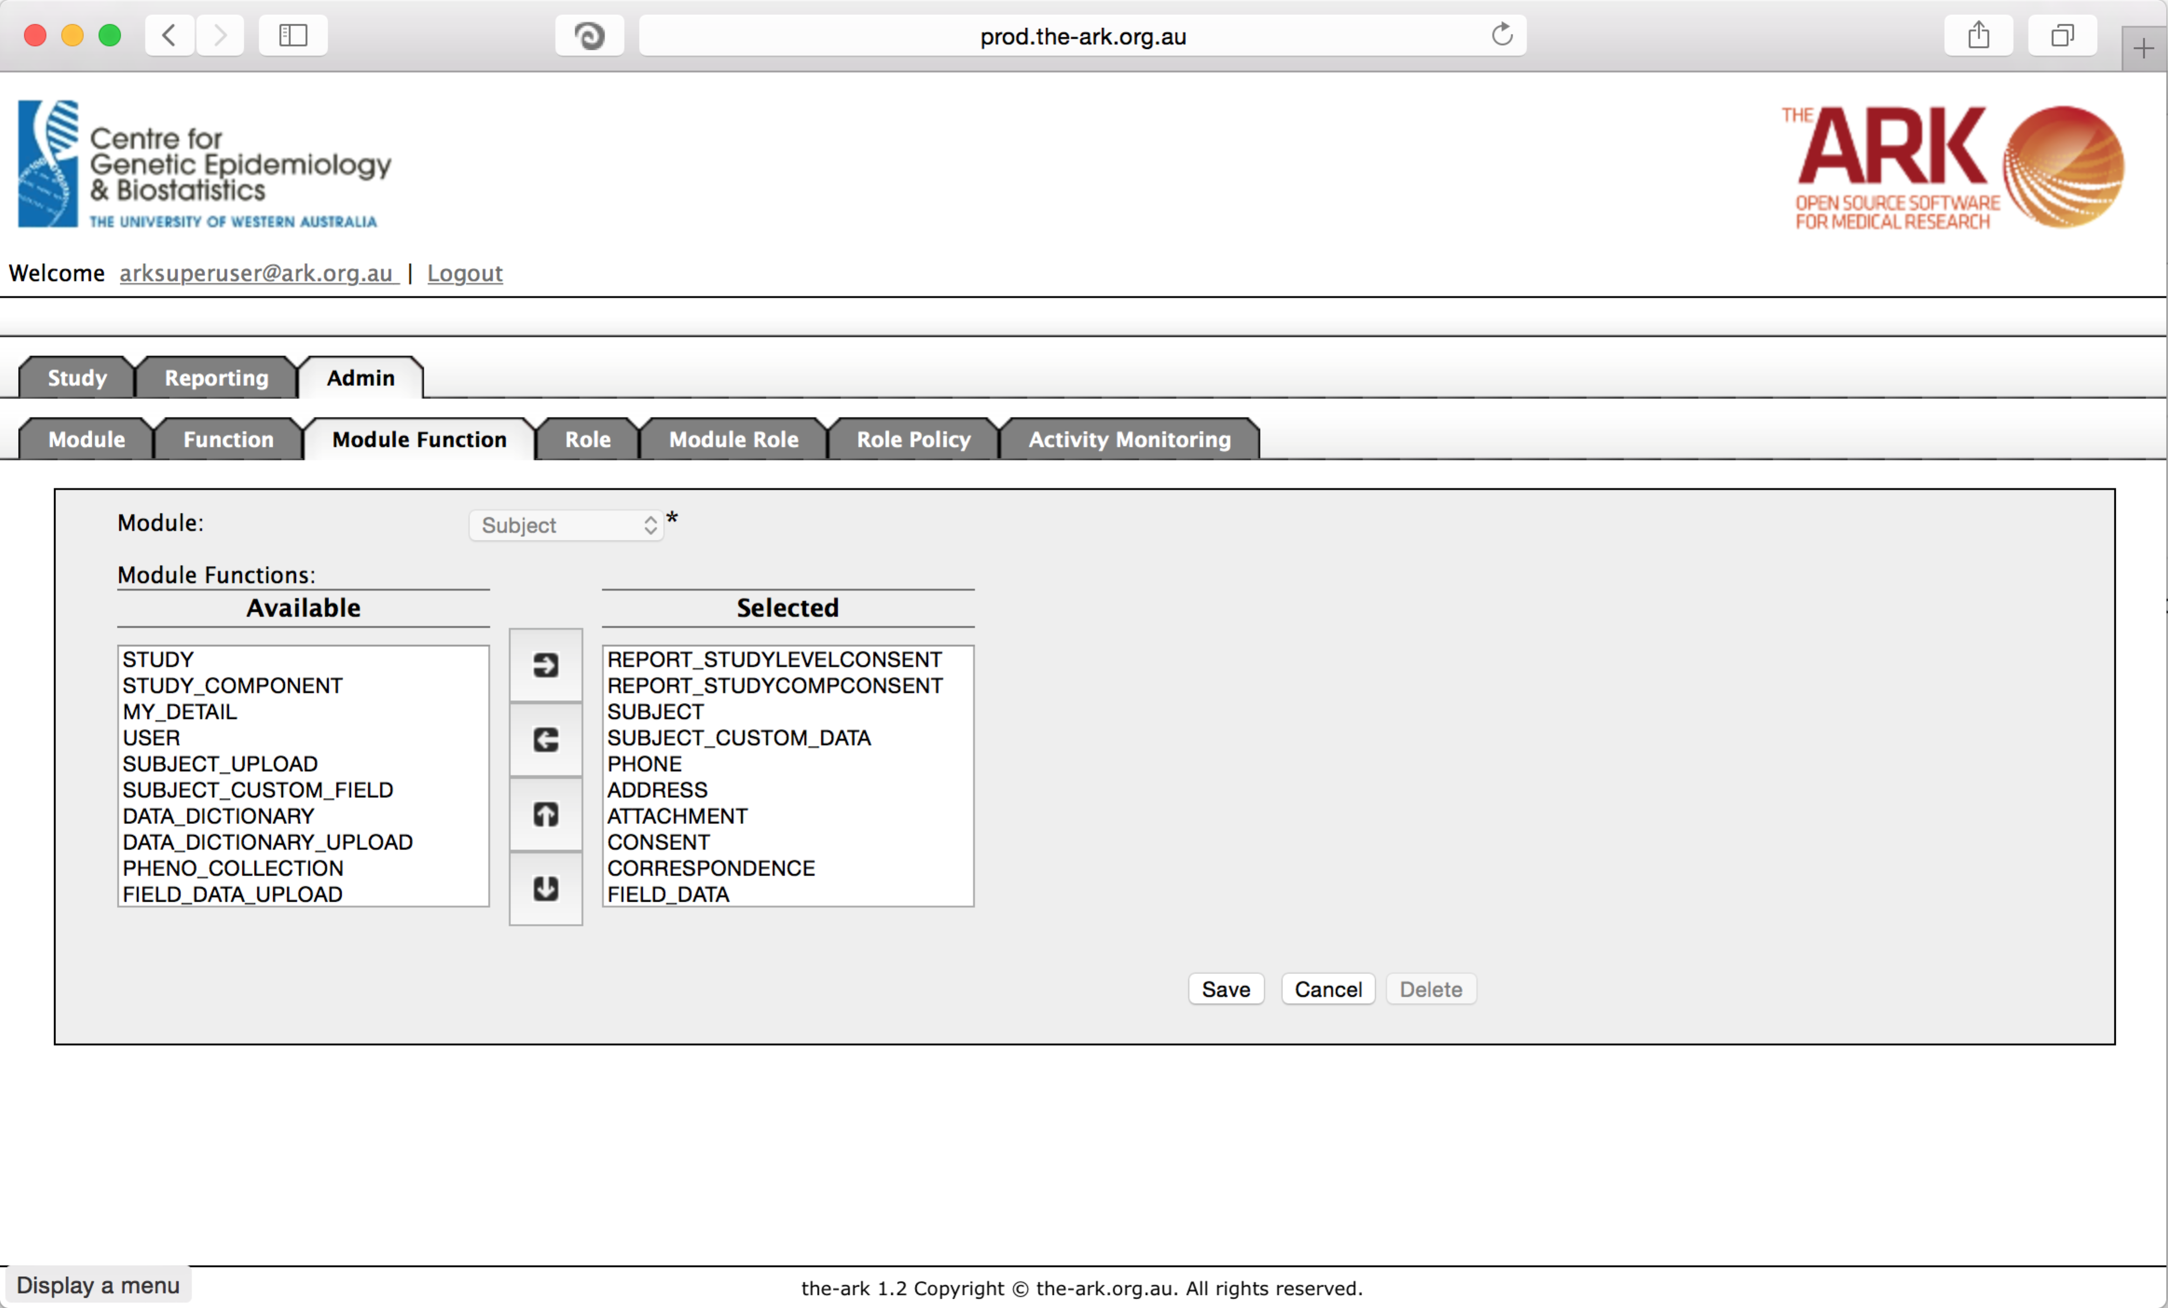

From here, you can simply add and remove modules or change their order (again: at your own risk, as we cannot guarantee dependency issues in Java code as we have many contributors now). The list of available module-functions is to your left, and the ordered list is to the right. Each module-function can be shifted up or down in precedence/order as well.

The next function we will look at is Roles. So far we have roles designed to give certain capabilities for each module. So far we have read-only (cannot modify in that module but can see everything), Data manager (can modify data but not the study structure and functionality itself) and Administrator (can change anything including the structure and functionality of a module itself) roles.

Again, this is a module, I would not recommend playing with too much without expecting downstream affects.

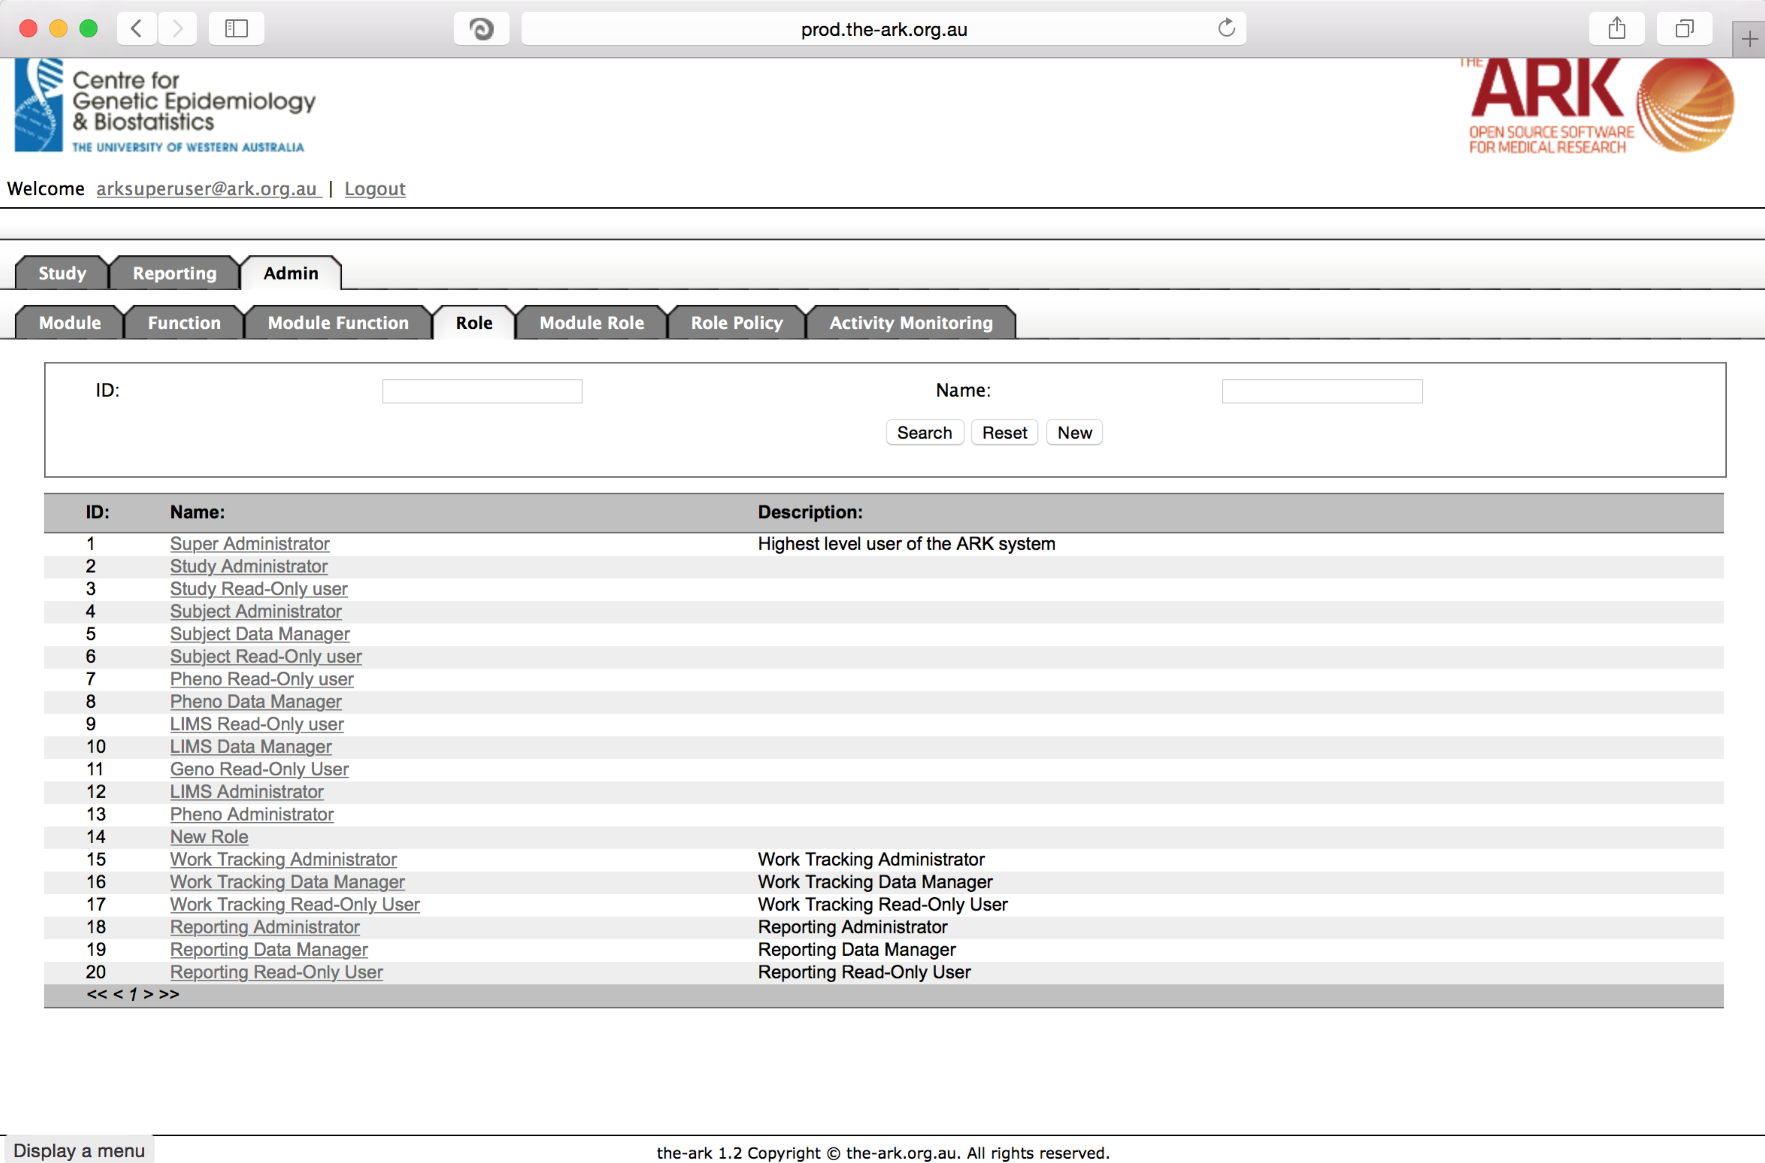

Module Role is the next function we will look at.

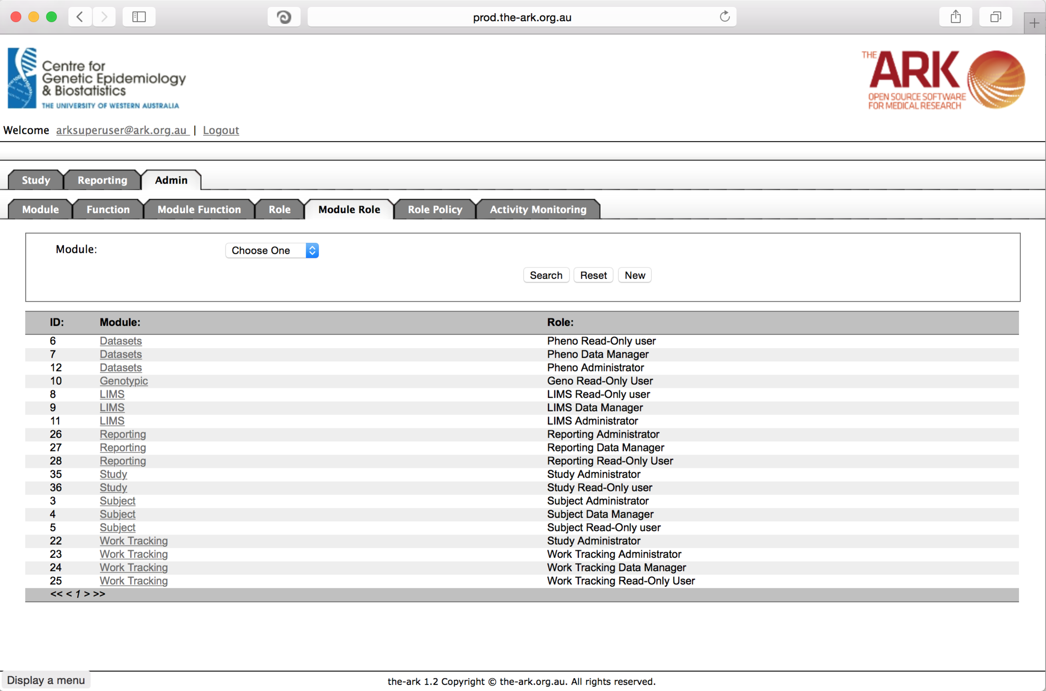

There is not a great deal of need to change this functionality unless creating new roles, in which case this is where you would associate that new role to the module. For example, if we intend to have a new role called “Obfuscated Read Only” where certain field could be hidden from even a low-security-read only person, in which case we simple move the role from “available” to “selected” for the given module. Then click save.

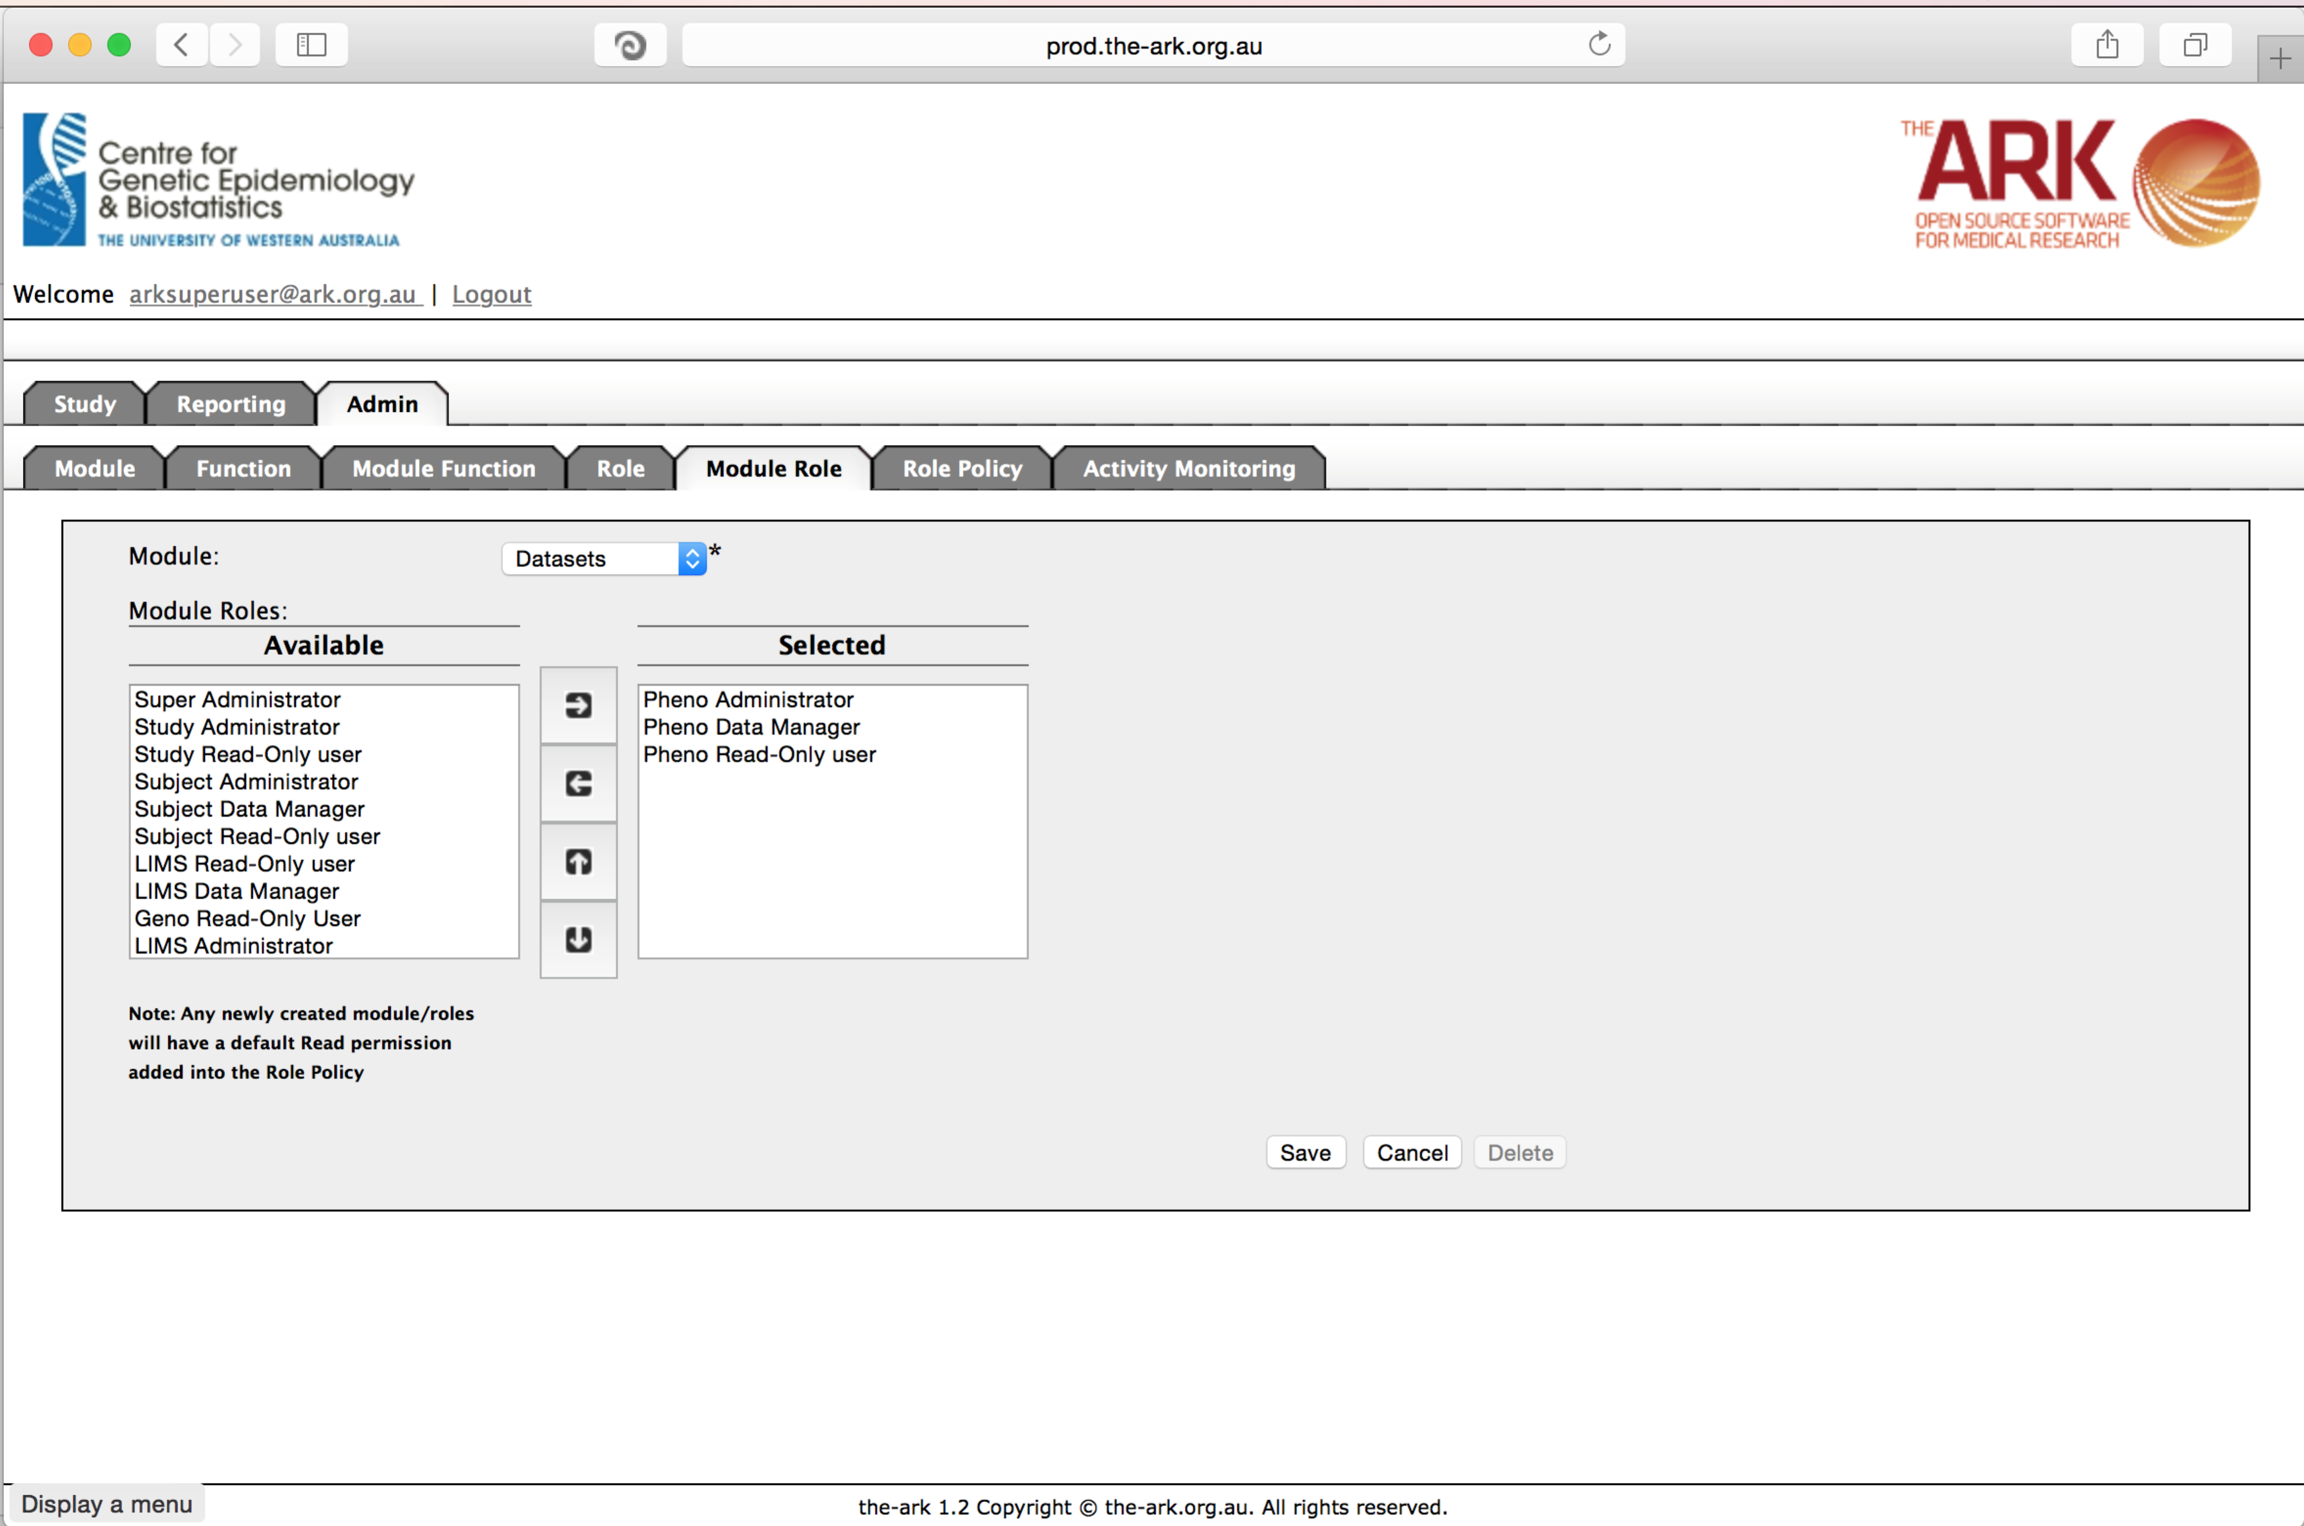

The next function is where we really start to coordinate all of these roles and the capabilities they will have within the application. Again, we try to have this inherently set up in our base scripts when you install The Ark. But if you wish to alter the set up, this is where you can. You can basically see for each role, module, function combination, you have the ability to allow create, read, update and delete functionality.

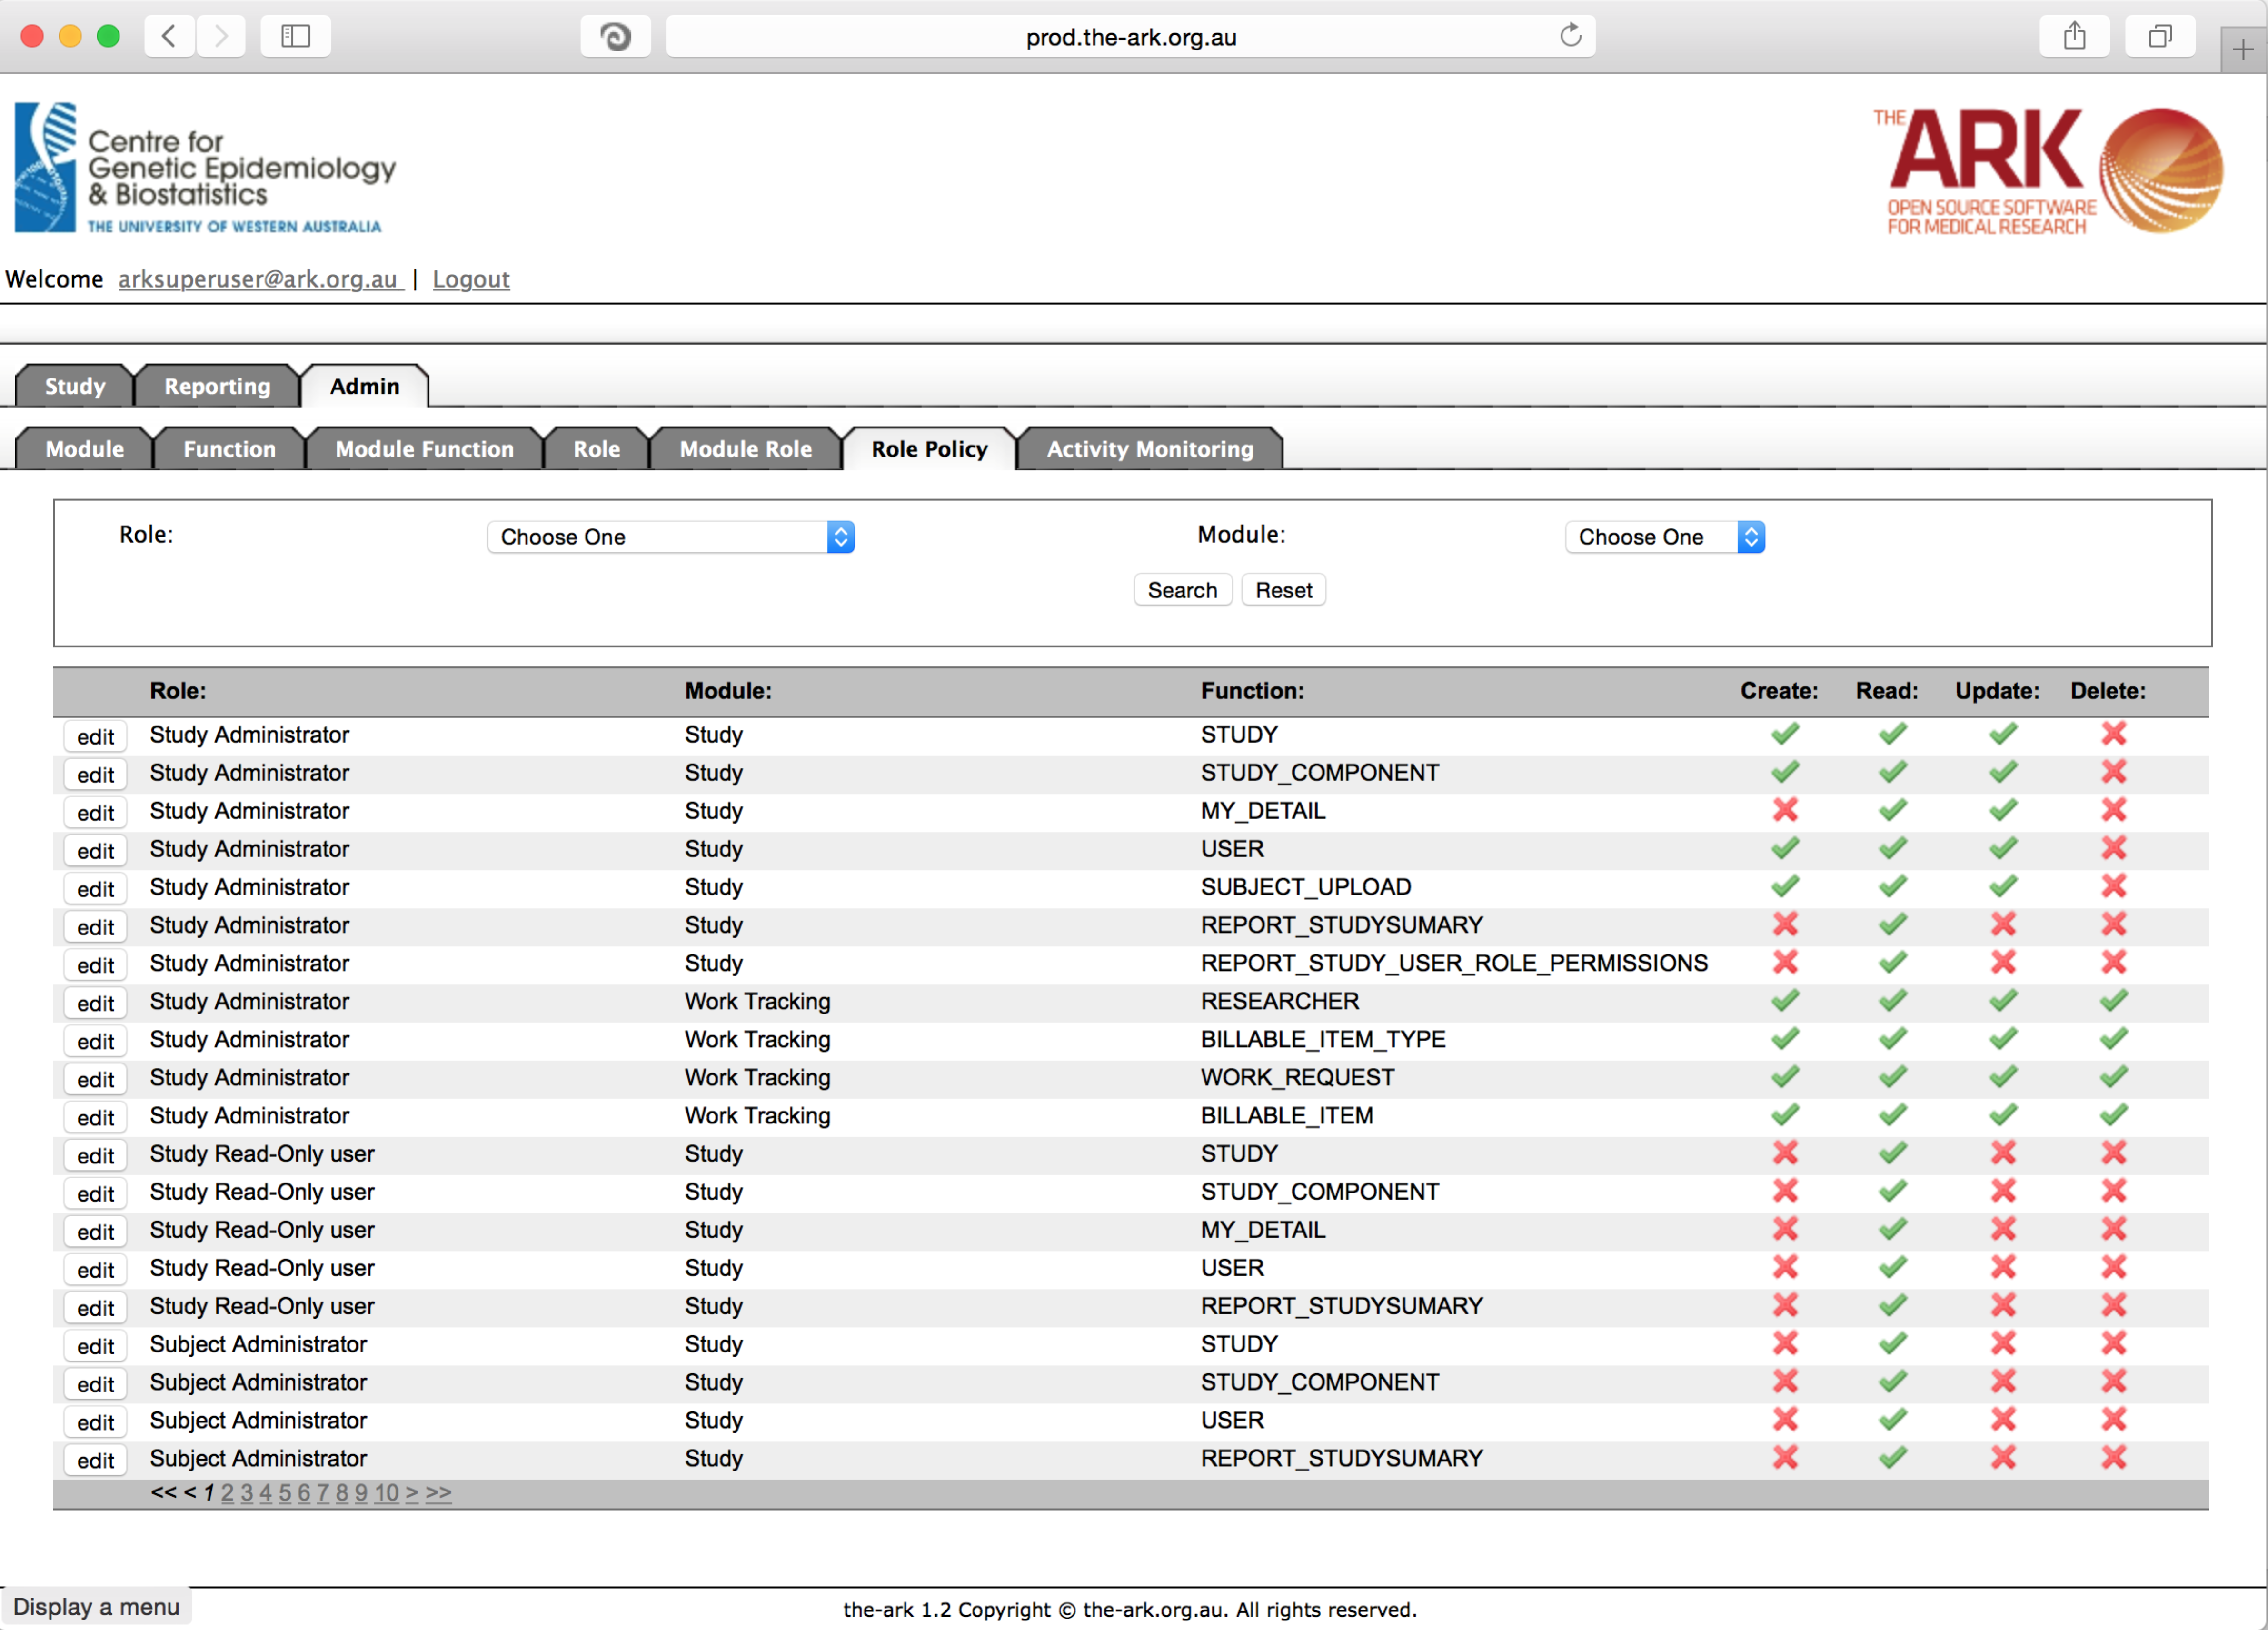

To alter any of these module-role-permission combinations, simply click the edit button.

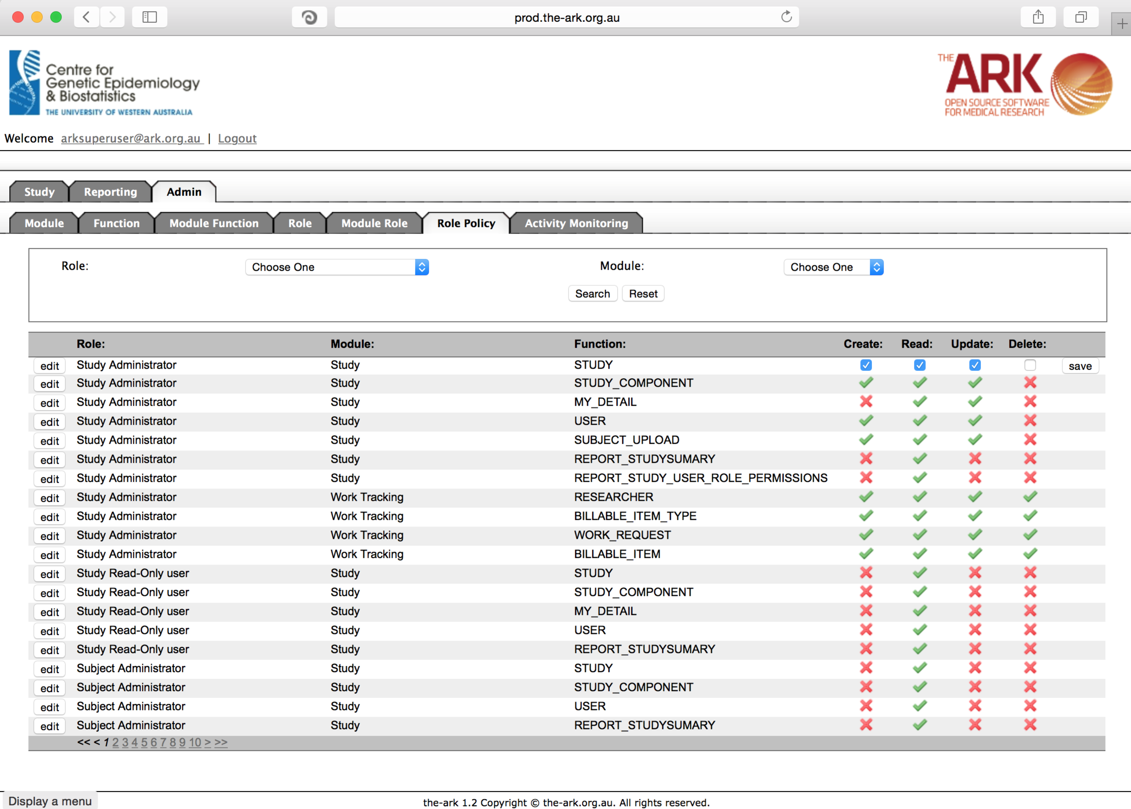

You will notice the ticks and crosses are now gone and you can select the radio boxes you wish to permit (select) or not permit (de-selected). Then simply click the save button.

The final functionality available in the Admin module is “Activity monitoring”. This function allows us to see who is logging into the system, from what IP address and when.

This can be useful in debugging who has been in the system and might have changed data in instances of confusion from users. It also may be useful to see if certain studies are being able to adequately use the functionality of The Ark. If resources are being heavily drained, it may be a useful debugging tool to see why. Please note though, that only the sessions since the app server’s last restart are available (eg; our app server has been up since 2014, oldest logins first, go to the end to see the latest logins).

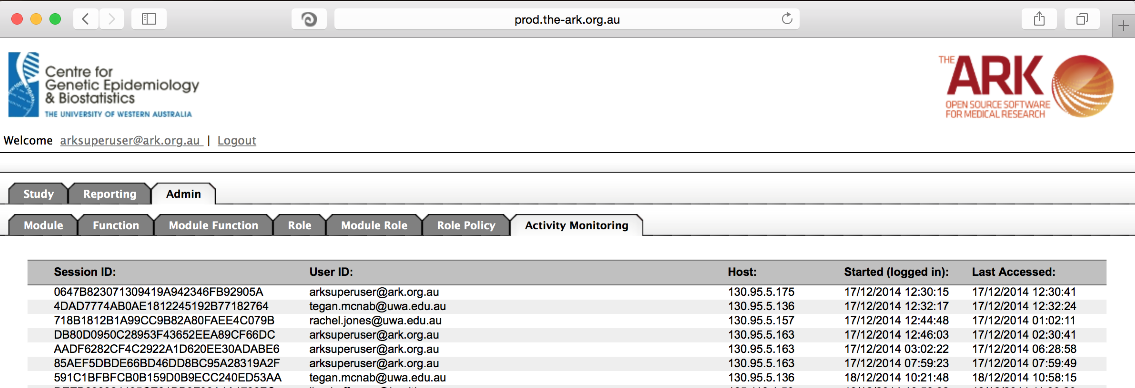

This module was particularly difficult to document without a great depth of programming knowledge. If you require any further guidance please feel free to ask our ark-informatics git hub group.

<https://github.com/The-Ark-Informatics/ark>